Project Name |  | Confidentiality Level
RKDBMS Project |  | For Recipients’ Reference Only
Project ID | Version | Document Code
Group 3 | 1.0

RKDBMS Software Requirements Specification



Copyright © Ruankosoft Technologies(Shenzhen), Co., Ltd.
. All Rights Reserved
Revision Record
Date | Revision Version | CR ID /Defect ID | Sec No. | Change Description | Author
03.05.2017 | 1.0 | 15309003 |  | Define the requirements of the project | Shin Kiho
Content
1 Introduction 6
1.1 Purpose 6
1.2 Scope 6
2 General description 6
2.1 Software perspective 6
2.1.1 About the Project 6
2.1.2 Environment of Product 6
2.2 Software function 6
2.3 Actors 6
2.4 User characteristics 6
2.5 Assumptions & Dependencies 7
2.6 System Use Case 7
2.7 Sub-module Functional Requirements 1 7
2.7.1 Functional Requirements1 7
2.7.2 Functional Requirements2 8
2.8 Sub-module Functional Requirements2 9
2.8.1 Functional Requirements1 9
2.8.2 Functional Requirements2 9
2.9 Data Information 9
3 Interface Requirements 9
3.1 User Interface 9
3.2 Software Interface 10
4 Overall Design Constraints 10
4.1 Hardware Limitations 10
4.2 Technology Limitations 10
5 Software Quality Attributes 10
6 Requirements Classification 10

Keywords: Words that will reflect main contents of the document.
Abstract:
List of abbreviations: Describe abbreviations in this document, full spelling of the abbreviation and Chinese explanation should be provided.
Abbreviations | Full spelling | Chinese explanation
DBMS | Database Management System

Introduction

Purpose
This manual describes user requirements for functions and performance of the Database Management System. The intended audience includes Users, Project administrators, Testers, Designers, Developers. The manual focuses on function requirements of Database Management System; clarifies mandatory functions, performance and interfaces of the developed software; assists system analysts and software developers in user demand-orientation.

Scope
The manual analyzes the logical model of the Database Management System from users' perspective. It answers the question "What does the system do?" by listing functions and services provided to clients. The manual omits development skills, but describes user requirements through demand analysis and model establishment. It is a common ground for game users, developers and other participants to communicate.

General description

Software perspective

About the Project
Database Management System is large-scale software which can manipulate and manage the database. It is used to establish, use and maintain the database, and called DBMS for short. It manages and controls the database in a unified manner to ensure the security and integrity of the database. The user accesses the data in the database through DBMS. The database administrator also maintains the database through DBMS. It can make many applications and users establish, modify and query the database through different methods at the same time or different moments. Most DBMS provide DDL (Data Definition Language) and DML (Data Manipulation Language) for users to define the schema structure and permission constraint of the database, and implement the data operations: add, delete, etc.

Environment of Product
This system is a Windows desktop window program. It stores the data with the file system of the operating system. It can implement the communication between the client and server through the network.

Software function
The functional structure diagram is as follows:
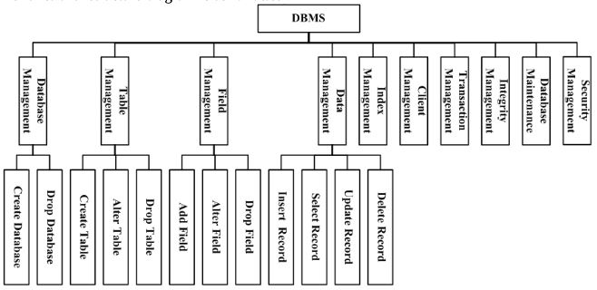

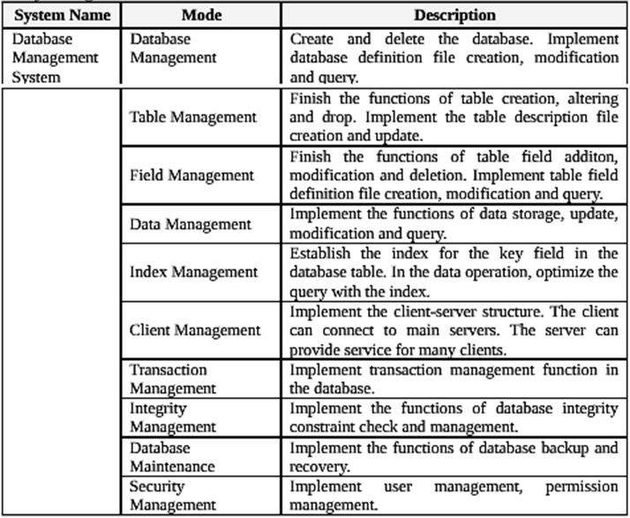

Actors
Database administrators, Database client users

User characteristics
The users of this system are the database administrators and the client users. The database administrator requires some database management knowledge, and can install, deploy, create, manage and maintain the database.
The client use requires some application operation knowledge, and can use this database to implement the functions of data storage, modification, query, etc.

Assumptions & Dependencies
This system generally uses the WINDOWS operating system, if users have additional operational requirements under the particular circumstances, the system should have a portable condition.

System Use Case
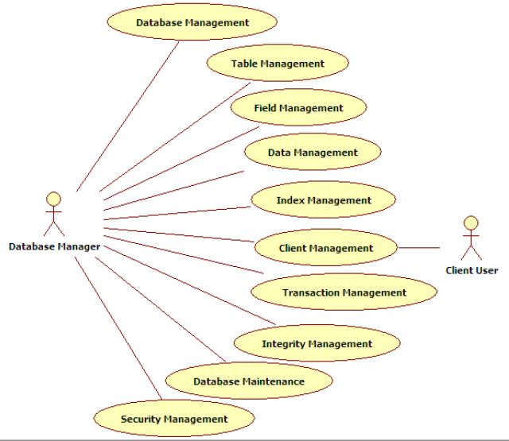

Sub-module Functional Requirements 1
1. Sub-module introduction
Create and delete the database. Implement database definition file creation, modification and query.
2. Sub-module use case diagram
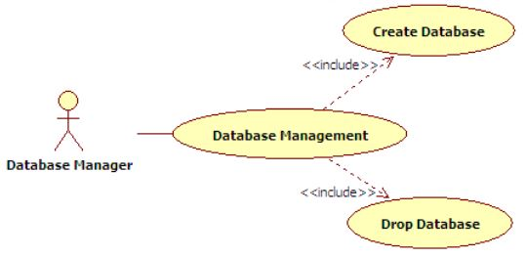

Functional Requirements1

Create Database
1. Introduction
Implement the function of database creation. Corresponding SQL statement: CREATE DATABASE <database name>. The database is divided into two types: user database and system database. The system database is database Ruanko created by the system when the system is created. This database can’t be deleted.
2. Inputs
Database name, database date file storage path, database creation time, database type.
3. Process
(1) Determine the validity of the database name.
The length of the database name can’t exceed 128 characters. If the name is too long, the database can’t be created and prompt the user. Determine whether the database name has existed. If it exists, the database can’t be created and prompt the user.
(2) Save the database information into database file ruanko.db.
Determine whether ruanko.db file exists under the system directory. If it exists, append to the file. If it doesn’t exist, create raunko.db file.
4. Output
Create or update database description file ruanko.db file, add or delete the database information.

Functional Requirements2

Drop Database
1. Introduction
Implement the function of database deletion. Corresponding SQL statement: DROP DATABASE <database name>. The database is divided into two types: the user database and the system database, the user database can be deleted, the system database is the database Ruanko created by the system when the system is created.

2. Inputs
Database name, database data file storage path, database creation time, database type.

3. Process
(1) To determine whether the database exists.
(2) To determine whether a user is using the database, if a user connection, you cannot delete.
(3) Delete the database information from the ruanko.db file.
(4) Delete all files related to the database.

4. Output
Delete database description file ruanko.db file database description information.

Sub-module Functional Requirements2

Functional Requirements1

Create Table
1. Introduction
Implement database table creation function. Corresponding SQL statement: CREATE TABLE <table name>. When the table is created, add the basic information of the table into the table information file of the current database. The table description file is: [Database Name].tb.

2. Inputs
Database name, table name, table definition file path, table integrity file path, table record file path, table index file path, table creation time, last modification time (is creation time), table field count ( initial is 0), total number of records in table ( initial is 0).

3. Process
(1) Determine the validity of the table name. The length of the table name can’t exceed 128 characters. If the name is too long, the table can’t be created and prompt the user. Determine whether the table name has existed. If it exists, the table can’t be created and prompt the user.
(2) Get the paths of four table definition files according to the rule. Table definition file path: [Table Name].tdf. Table integrity file path: [Table Name].tic. Table record file path: [Table Name].trd. Table index file path: [Table Name].tid.
(3) Save the table information to table description file “[Database Name].tb” file. If the table information file does not exist, create the file. If it exists, append the record to the end of the file.

4. Output
Create or update the table description file: “[Database Name].tb”.

Functional Requirements2

Alter Table
1. Introduction
Implement database table modification function. Corresponding SQL statement: ALTER TABLE <table name> <alter table action>. When the table field is added, update the field count, record count, modification time or path in the table.

2. Inputs
Database name, table name, table definition file path, table integrity file path, table record file path, table index file path, table creation time, last modification time (is current time), table field count, total number of records in table.

3. Process
(1) Through the database name and table name, find the table information file, get the table modification information.
(2) Set the modification time.
(3) Update the table information.

4. Output
pdate table description file: “[Database Name].tb”.

Data Information

Data Type
System data type | Description | Size | Program data type
INTEGER | Integer | 4byte | int
BOOL | Boolean type | 1byte | bool
DOUBLE | Float type | 2tyte | Double
VARCHAR(n) | String type, maximum length is 255, ended with “\0” to mark the end of a string. | (n+1)byte | Char[n+1]
DATETIME | Data time type | 16byte | SYSTEMTIME

2.9.2 Integrity

2.9.2.1 Entity Integrity

PRIMARY KEY

2.9.2.2 Referential Integrity

FOREIGN KEY

2.9.2.3 User-defined Integrity

1. CHECK

2. UNIQUE

3. NOT NULL

4. DEFAULT

5. IDENTITY

2.9.3 Database File
Type | File | Name | Remark
Data definition file | Database description file | ruanko.db | Save the database information
Data definition file | Table description file | *.tb | Save the field information
Data definition file | Table definition file | *.tdf | Save the integrity constriants
Data definition file | Integrity description file | *.tic | Save the definition of the index
Data definition file | Index description file | *.tid
Data file | Record file | *.trd
Data file | Index data file | *.ix
Data file | Log file | *.log

Interface Requirements

User Interface
For most users, screens are larger than 17 inches, the resolution is 1024X768，and software interface should adapt to the screen dimension.

Software Interface
This is a windows application program with GUI.

Overall Design Constraints

Hardware Limitations

Minimum configuration on a computer:

CPU:1 GHZ, Memory :128 MB

Technology Limitations

File format: binary mode file format.

Coding standard: C++ coding standard

Software Quality Attributes
5.1 Reliability
Adaptability: New services and functions can be easily added to the system on the basis of its basic functions, without affecting the architecture of the original website system. The system can adapt to browsers of multiple versions.
Fault tolerance: In the case of system crashes, memory insufficient, it will not cause the system failure and the system can normally power off & restart.
Recoverability: The system should be able to run properly after a fault is resolved.
5.2 Usability
Usability: The interface design should be reasonable, concentrating system functions and making the system user-friendly. The system should block users' illegal input data or operations, provide wizards and notes for complex processing, and provide users with handy help information.

Requirements Classification
Requirement ID | Requirement Name | Classification
3.2.1 | Create Database | A
3.2.2 | Drop Database | C
3.3.1 | Create Table | A
3.3.2 | Alter Table | C
3.3.3 | Drop Table | C
3.4.1 | Add Field | A
3.4.2 | Alter Field | C
3.4.3 | Drop Field | B
3.5.1 | Insert Record | A
3.5.2 | Update Record | B
3.5.3 | Select Record | A
3.5.4 | Delete Record | C
3.6 | Index Management | A
3.7 | Client Management | B
3.8 | Transaction Management | C
3.9 | Integrity Management | B
3.10 | Database Maintenance | C
3.11 | Security Management | C

